How to Develop a Doctor Appointment App Like Practo?
Focus Keyword: Doctor Appointment App
Meta Title: How to Develop a Doctor Appointment App Like Practo
Meta Description: Learn how to develop a doctor appointment app like Practo with features, cost, tech stack, and step-by-step development process. A complete guide for startups.
Feature image:
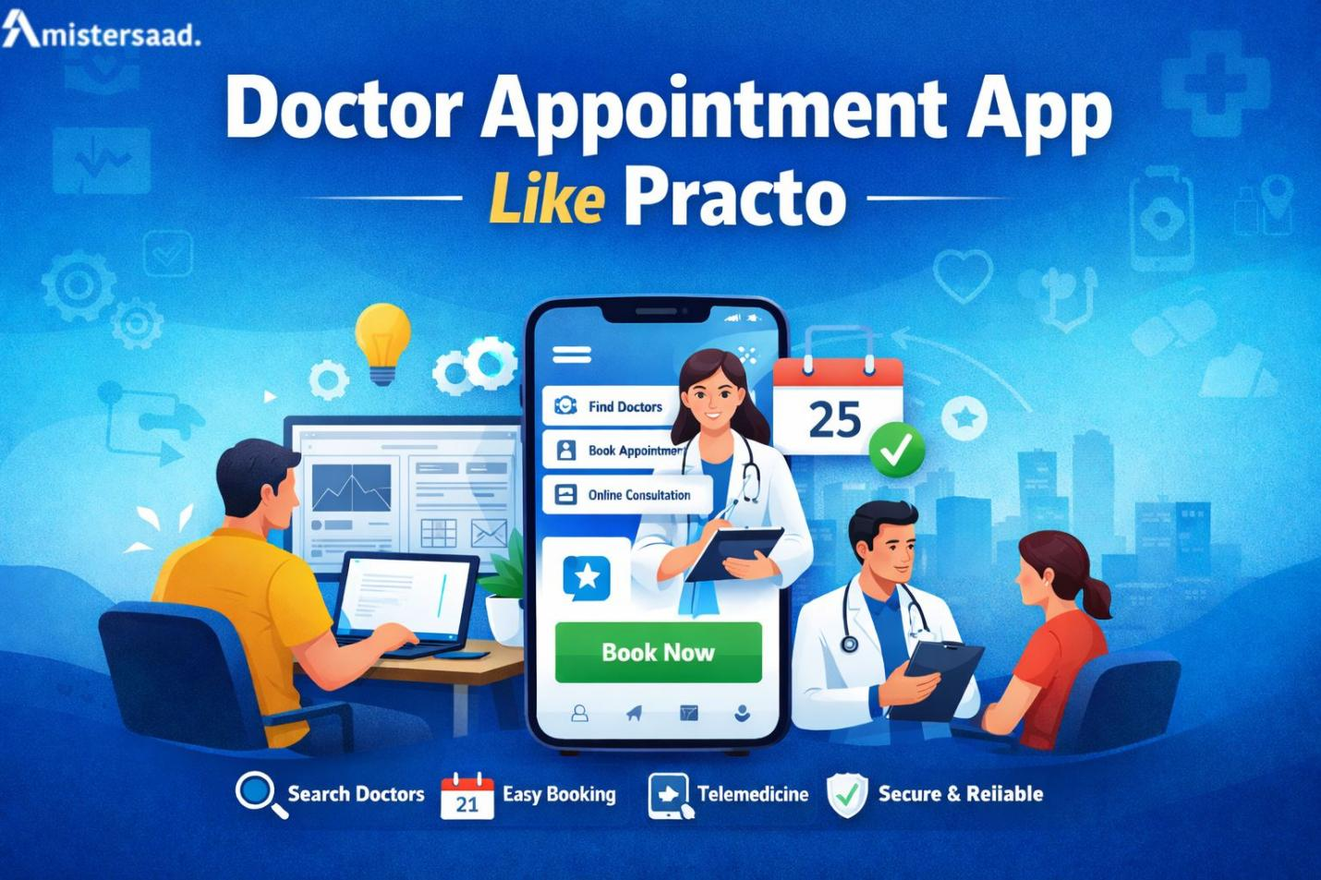
Introduction
Booking a doctor should feel simple today. Many patients still face delays. Clinics stay overloaded every day. Phone calls waste valuable time. I experienced this frustration personally during urgent situations. Digital healthcare platforms now change this reality. Appointment apps bring speed and clarity. Patients book visits within seconds. Doctors manage schedules without chaos. Building such an app needs strategy and experience. This guide explains the full development journey. You will gain practical insights. The focus stays on trust, performance, and long-term success.

Understanding the Healthcare Booking Problem
I learned this problem deeply through years of healthcare projects. Patients want quick access to trusted doctors. Doctors need organized schedules. Manual systems fail often. An appointment app removes confusion. It shows doctor availability clearly. It reduces waiting times. It improves patient satisfaction. Many clinics now demand digital solutions. A skilled App Developer Dubai understands these local healthcare needs well.
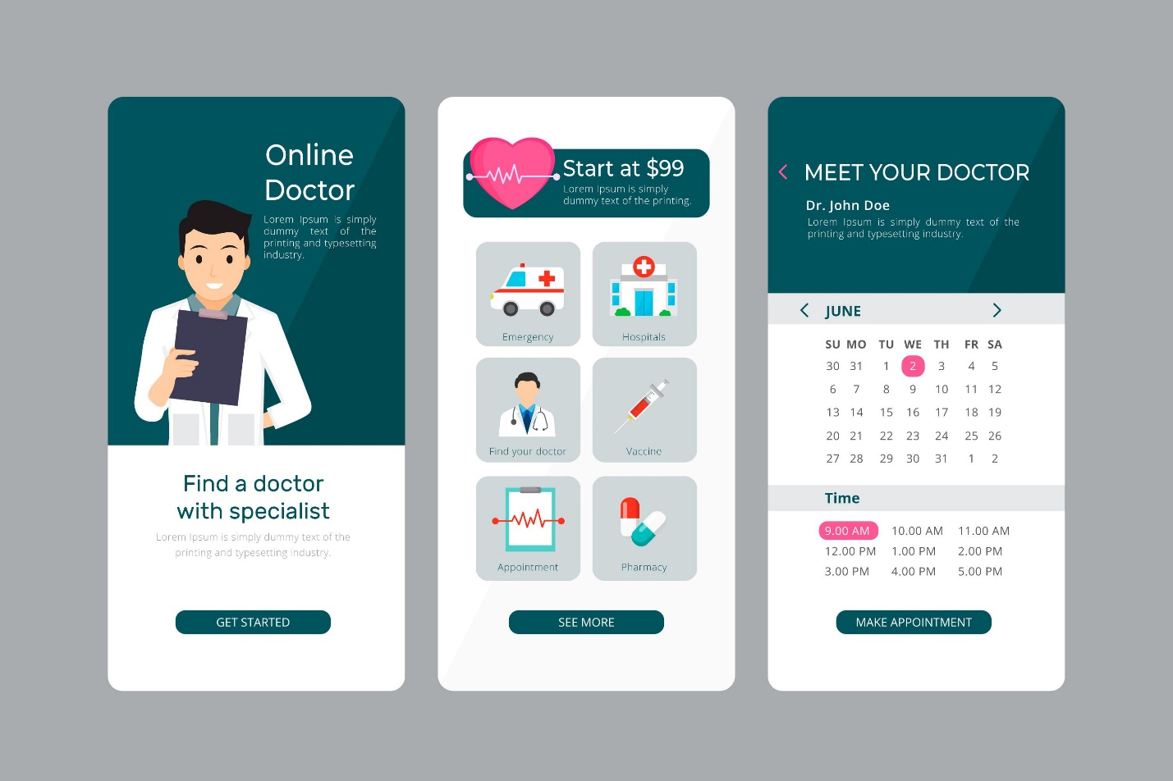

Planning the App Structure and Flow
I always start with strong planning. Clear structure saves future costs. The app needs simple navigation. Users must find doctors quickly. Booking steps should remain short. Payment flow must feel secure. Notifications must stay timely. Proper planning avoids later confusion. A professional Freelance App Developer Dubai helps design efficient app workflows.

Core Features for Patients
I have built many patient focused healthcare platforms over years. Patients always expect speed and simplicity. Fast doctor search saves valuable time. Smart filters help users choose the right specialist. Location based results improve accuracy. Appointment booking must feel smooth and quick. Complicated steps frustrate users easily. Clear booking confirmation builds confidence. Automated reminders reduce missed appointments effectively. Patients rely on timely notifications. Online payments increase overall convenience. Secure payment options improve trust instantly. Reviews help users make informed choices. Honest feedback strengthens platform credibility. Each feature must solve a real patient problem. A skilled Mobile App Developer Dubai ensures every feature works reliably and efficiently.

Doctor Management and Scheduling System
Doctors need simple control panels. I have seen doctors reject complex systems. Profiles must remain editable. Availability updates should work instantly. Appointment conflicts must never happen. Automated schedules save effort. Reports help doctors track performance. Smart systems increase doctor retention. Strong Mobile App Development Dubai expertise makes this possible.
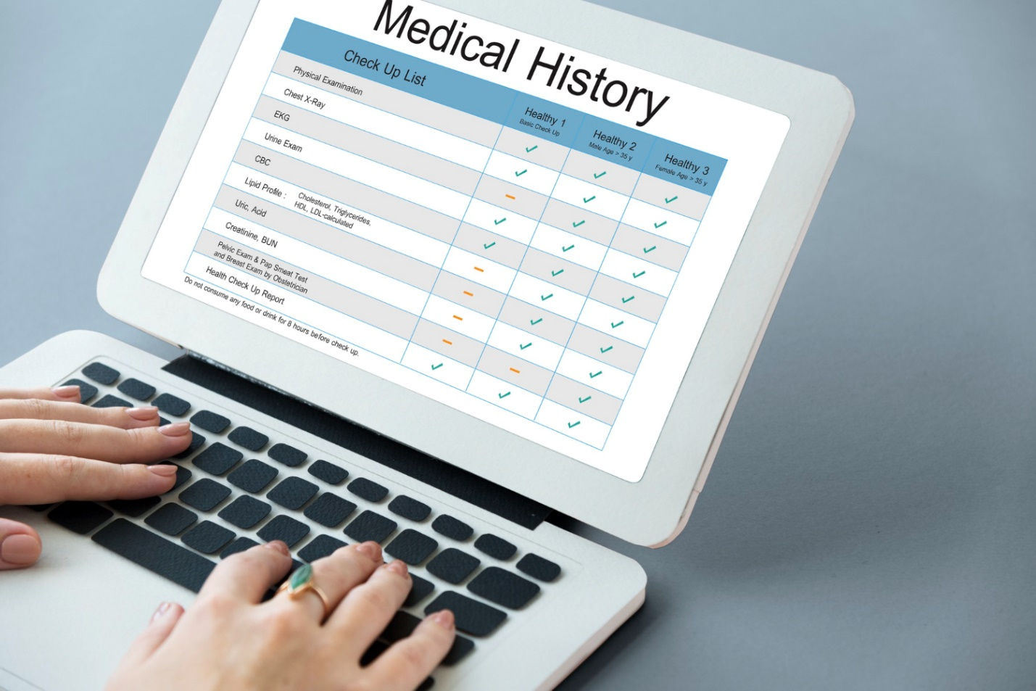

User Interface and Experience Design
Good design builds instant trust. I learned this through many user tests. Buttons must feel intuitive. Fonts should stay readable. Colors must feel calm. Navigation should feel natural. Elderly users need clarity. Simple design improves adoption rates. Experienced Freelance Mobile App Development Dubai teams focus on usability.
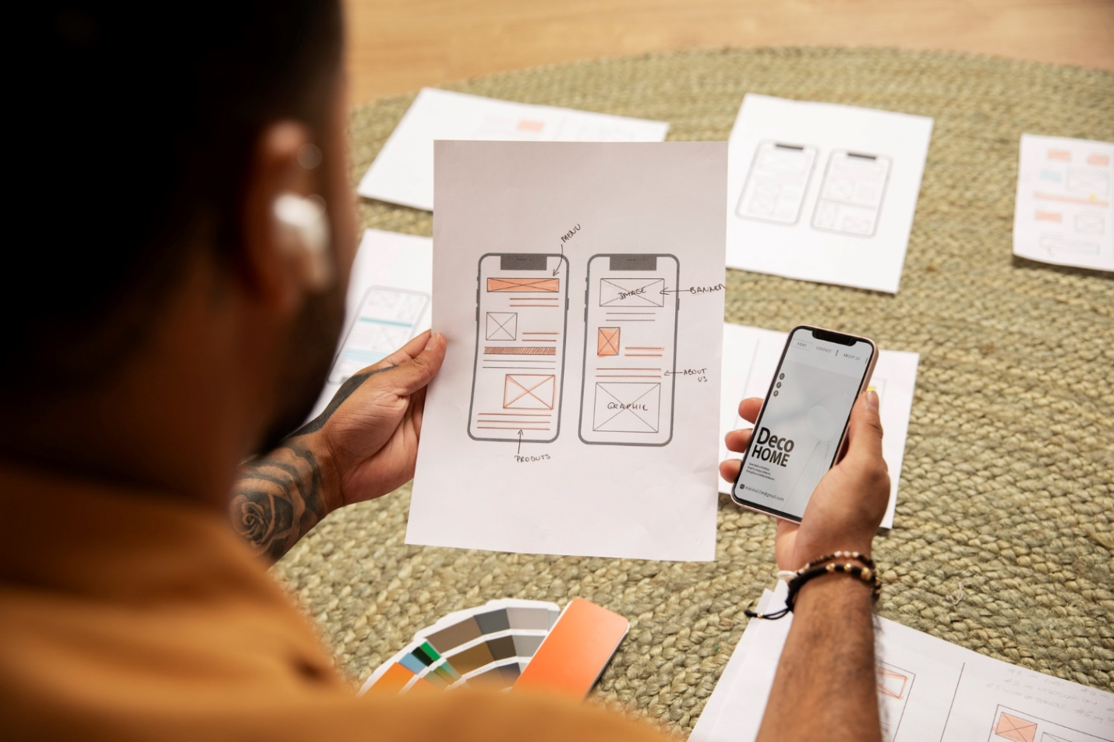

Security, Privacy, and Compliance
Healthcare data needs strong protection. I handled sensitive patient information carefully. Encryption protects personal records. Secure logins prevent misuse. Compliance builds legal safety. Data backups avoid loss. Privacy policies increase confidence. Security failures destroy platforms quickly. Expert teams never compromise safety standards.

Choosing the Right Development Partner
I have worked in this field for 25 years. Choosing wisely matters greatly. Experience reduces risks. Industry knowledge improves outcomes. Communication ensures clarity. Long term support ensures growth. This approach defines Mistersaad and its trusted development philosophy. Practical experience always delivers better healthcare solutions.

Testing, Launch, and Continuous Improvement
Testing reveals hidden issues early. I always recommend real user testing. Bug fixes improve stability. Soft launches reduce risks. Feedback improves features. Updates keep users engaged. Marketing increases visibility. Continuous improvement ensures long term success. Healthcare apps need constant refinement.

Conclusion
Building a doctor appointment app needs expertise and patience. Every step matters. Planning creates strong foundations. Design improves trust. Security protects users. Continuous updates drive growth. With the right partner, success becomes achievable. I recommend working with experienced professionals. mistersaad brings decades of healthcare development trust. Contact today to start your digital healthcare journey.

FAQs
What is the first step in developing a doctor appointment app?
Start with market research and user pain points.
How long does app development usually take?
Development often takes four to six months.
Is data security important for healthcare apps?
Yes, patient data protection remains critical.
Can small clinics use appointment apps?
Yes, apps suit clinics of all sizes.
Do appointment apps need regular updates?
Yes, updates improve security and user experience.
How can users trust a healthcare app?
Strong security, reviews, and transparency build trust.
